A NOVEL CELL PENETRATING PEPTIDE, CARDIAC TARGETING PEPTIDE APPEARS TO UTILIZE CARDIAC CHANNELS FOR TRANSDUCTION
M. Zahid
University of Pittsburgh, Pittsburgh, PA, USA

Background: Cell penetrating peptides are small peptides able to carry cargo across cellular membranes resulting in internalization of the intact cargo. A combinatorial in vitro and in vivo approach lead to the identification of a 12-amino acid peptide, APWHLSSQYSRT, which we termed Cardiac Targeting Peptide (CTP), because of its ability to transduce the mouse heart tissue specifically and efficiently after an intravenous injection. CTP has the potential to be a novel delivery tool for the heart for both diagnostic and therapeutic purposes. We now present the result of studies undertaken to elucidate CTP’s mechanism of transduction.
Methods and Results: Neonatal mouse hearts were harvested and cardiomyocytes (CMCs) isolated. Mouse embryonic fibroblasts (MEFs) were used as negative controls. CTP was synthesized dually labeled with 6-carboxyfluoroscein and Rhodamine, the latter via an ester link, susceptible to cleavage only by intracellular esterases. Hence, internalization and red fluorescence could not result from membrane attachment or fixation artifact alone. Cells were incubated with 25uM of CTP and showed robust transduction of CMCs within 10 minutes, with essentially no uptake by MEFs. This transduction was statistically significantly enhanced by increasing extracellular K+ ion concentration to 20mM (p-value=0.03;Figure), with this enhancement in uptake abrogated both by calcium channel inhibitor Verapamil (Vpml) and Na-K+-ATPase inhibitor Digoxin (Dgxn). Increased CTP uptake secondary to cell death/apoptosis was ruled out by restoring extracellular K+ concentration to normal levels and resumption of CMC contractile function. Rhodamine with cleaved ester link alone was not internalized by CMCs.
Conclusions: CTP rapidly enters CMCs in a cell specific manner. This transduction is enhanced by increasing the Na-K ATPase pump activity by increasing extracellular K+ concentration, implying that CTP is using this ion channel for cell entry. Further studies, perhaps utilizing mass spectroscopy, are needed to identify the specific binding partner of CTP.
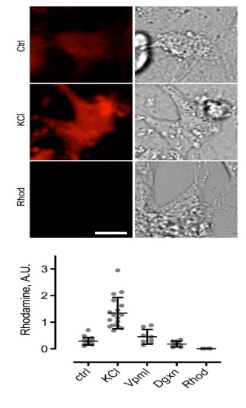
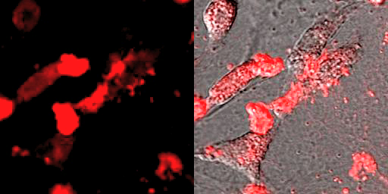
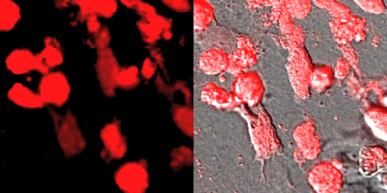
CTP
CTP + K

